Homebrew
# Source: AI Source: Provided by: [Data Path: Persons Table -> ID Column: 1, Name_En Column: Motasem Essam] -> From: [ChatGPT] on [1/26/2026]
Homebrew is a package manager for macOS (and Linux).
It allows you to install, update, and manage software packages easily from the command line. Think of it as the macOS equivalent of apt (Debian) or dnf/yum (Red Hat).

Key Features
# Source: AI Source: Provided by: [Data Path: Persons Table -> ID Column: 1, Name_En Column: Motasem Essam] -> From: [ChatGPT] on [1/26/2026]
- Installs command-line tools, applications, and libraries.
- Automatically handles dependencies for software.
- Can also be used on Linux (Linuxbrew).
- Installs software without requiring root access by default.

Common Commands
# Source: AI Source: Provided by: [Data Path: Persons Table -> ID Column: 1, Name_En Column: Motasem Essam] -> From: [ChatGPT] on [1/26/2026]
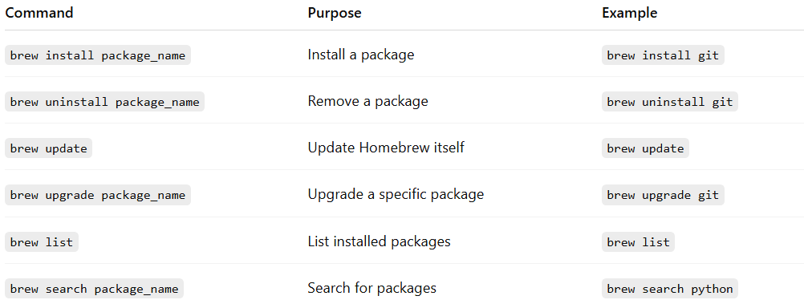
Command | Purpose | Example
brew install package_name | Install a package | brew install git
brew uninstall package_name | Remove a package | brew uninstall git
brew update | Update Homebrew itself | brew update
brew upgrade package_name | Upgrade a specific package | brew upgrade git
brew list | List installed packages | brew list
brew search package_name | Search for packages | brew search python

Example
# Source: AI Source: Provided by: [Data Path: Persons Table -> ID Column: 1, Name_En Column: Motasem Essam] -> From: [ChatGPT] on [1/26/2026]
Install Python on macOS:
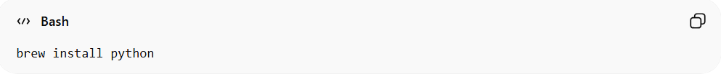
brew install python
Check the version:
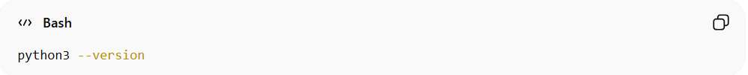
python3 --version

✅ Summary:
# Source: AI Source: Provided by: [Data Path: Persons Table -> ID Column: 1, Name_En Column: Motasem Essam] -> From: [ChatGPT] on [1/26/2026]
Homebrew = system-level package manager for macOS (and Linux) that installs and manages software, handles dependencies, and simplifies command-line software management.

